**PHYS 4270 / 5390 3.0 - Astronomical Techniques**

**Winter-Term Project - Part 2/2[1]**

**Spectroscopy**

**Due: 10 pm – Monday 12 April 2021**

# Introduction

In the fall-term assignment, you acquired, reduced and calibrated stellar *photometric data*. In this assignment, you will be provided with *long-slit spectroscopic and calibration data* for a number of red dwarfs that formed the basis of a publication by Dawson and De Robertis (whose interests include the kinematic properties of red dwarf stars).

Spectroscopic data reductions are conceptually more challenging than photometric data reductions. In the former, light is dispersed in wavelength and light from different parts of the slit falls on different areas of the detector. Spectroscopic data are arguably richer in information content than purely photometric data, though more challenging to acquire and interpret. But the extra effort is worth it.

Unlike in photometry, the entire CCD is normally not illuminated in long-slit spectroscopy; only a portion of the CCD representing the projection of the slit is read out. Even this section may be larger than required because of vignetting, etc.

A detailed users’ manual for the reduction of long-slit CCD data using IRAF is provided on the course website for reference (“A User’s Guide to Reducing Slit Spectra with IRAF” by Massey, Valdes and Barnes).

# Bias and Flat-Field Corrections

Spectroscopic data require corrections for a bias (and dark current if the CCD is not cryogenically cooled) as well pixel-to-pixel quantum efficiency differences which is corrected by a flat field (i.e., from a continuum lamp, a tungsten lamp in this case). (The data for this project are cryogenically cooled and therefore dark current may be ignored.)

The calibration images, including relevant biases and flat fields, can be downloaded as FITS files from the course (eClass) website, as can the stellar data and the associated lamp (also called “arc” or “arc lamp”) data. Grads will reduce all ten stellar (plus associated arc) spectra. Undergrads will consult Table 1 to determine which two stars each should choose. *Please state clearly in your report the spectra you chose and why*.)

|  |  |  |  |  |
| --- | --- | --- | --- | --- |
| Last Digit of Student Number | Stellar and Arc Spectrum to Use |  | Second-last Digit of Student Number | Stellar and Arc Spectrum to Use |
| 0 or 1 | A01s & A01a |  | 0 or 1 | B01s & B01a |
| 2 or 3 | A02s & A02a |  | 2 or 3 | B02s & B02a |
| 4 or 5 | A03s & A03a |  | 4 or 5 | B03s & B03a |
| 6 or 7 | A04s & A04a |  | 6 or 7 | B04s & B04a |
| 8 or 9 | A05s & A05a |  | 8 or 9 | B05s & B05a |

Table 1: Selection of Stars Based on Undergraduate Student Number

Once the data are in the same directory on cosmos, change to your IRAF directory and, as usual, launch two more windows; an *xgterm* and a *ds9* window by typing **xgterm &** and **ds9 &**. Then launch IRAF using the **cl** command as usual from the *xgterm* window.

To get a better sense of the spectroscopic data format, display one of the flat fields in the *ds9* window using the command **display flat1.fits** (assuming one of the spectroscopic flat fields is named ”flat1.fits”). Notice the image is a long, thin rectangle that is displayed vertically in *ds9*. The dispersion direction is along columns or in the vertical direction, whereas the spatial direction is along lines (or rows or in the horizontal direction).

[Many of you are now in the process of becoming proficient with IRAF. As noted before, despite IRAF’s clunky, command-line structure, it is still *the* (general) data-reduction program of choice for optical/NIR astronomers around the world. In the fall-term assignment, the reduction procedure proceeded via command-line incantations. For example, **imstat abc.fits** was used to find various statistical parameters of the image **abc.fits**. If I had asked you only to find the *minimum* and *maximum* of the image **abc.fits**, you could have issued the command:

**imstat abc.fits fields=image,min,max**

You could have found this out by consulting the **imstat** help page. There is a better way, however. IRAF allows the use of an interactive screen editor to edit the parameter files associated with each utility. A parameter file is a list of possible options that are recognized by a given utility. One can see all and edit any of the options for a particular utility, allowing users to get the most out of their data. From an xgterm window, type **epar imstat** (where **epar** is the parameter-file editor). If IRAF is installed properly, you will find yourself in a simple screen editor, staring at the parameter set for the utility, line by line. You can use the up/down arrow keys to access a particular parameter, which can be changed/edited. Optional parameters are in parentheses, “( …)”. Required parameters are *not* in parentheses. For **imstat**, only the name of the image is required. Suppose you scroll down to the **fields** line. You can then simply start typing, *image,min,max* followed by a carriage return. You can then save the session and exit the editor by typing **:wq** ; “w” stands for write and “q” stands for quit. If you then issue **imstat** without anything else, you will see a result exactly as you obtained above. Note, however, that every time you issue **imstat** thereafter you’ll get the same result. To return to the default set of parameters, you can issue **unlearn imstat** and things will return to “normal.” The editor is primitive and can cause sophisticated GUI’ists much grief. By the way, beware of the “backspace” key; it doesn’t really work in **epar**. Use the left / right arrows and “delete” instead.

(If this editor does not work for you, no worries. All the instructions below assume a purely command-line session. Good luck to those who will try this option in their quest to become IRAFers first-class.)

Returning to the object, some CCD pixels are simply not illuminated by the slit, unlike in direct imaging/photometry. This can be seen clearly by plotting some cuts through the image in another window. To do this, issue the command (for example),

**implot flat1.fits**

A graphics plotting window should appear on your screen with the title, *irafterm*. (You may have to click on the top bar of the window to render it active.) The default plot for any image is a plot along columns of the middle line, 512 in this case. Suppose you wish to plot along the average of a *sum* of lines, say, lines 350 to 475. In this case, with the cursor in the irafterm window, type:

**:l 350 475**

followed by a carriage return. You should then see the old plot disappear followed by the new plot including amended text now indicating that the plot is an average of the relevant lines which is illustrated in Figure 1. Now try plotting the average of columns 50 to 90. (Yes, you need to type **:c 50 90** followed by a carriage return.)

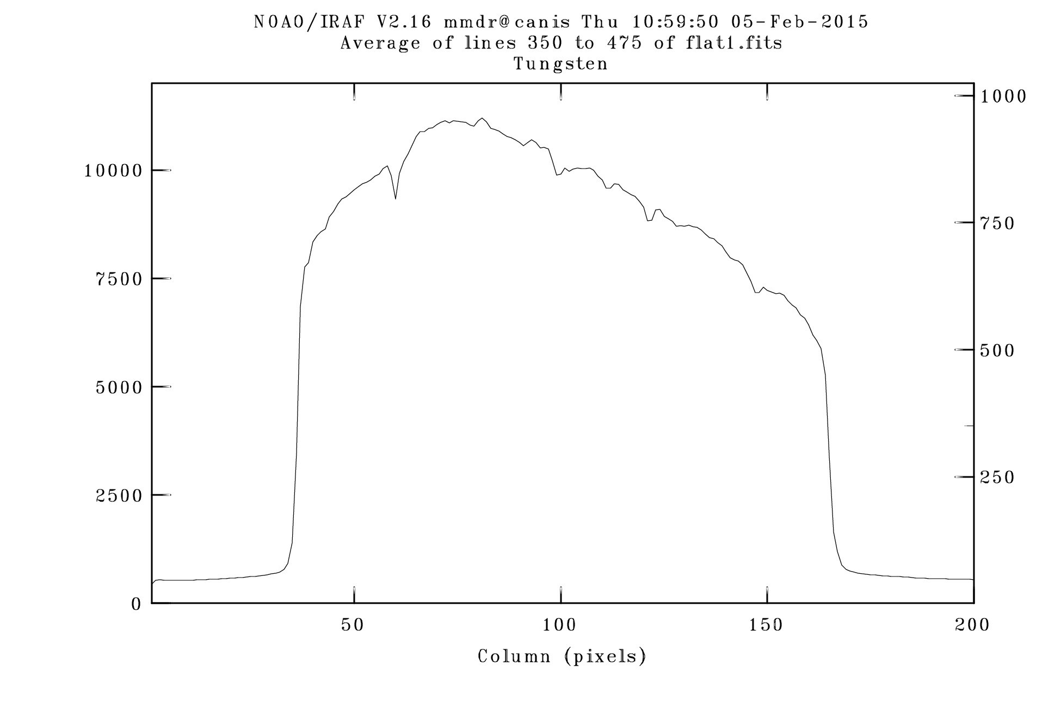

Figure 1: A Spatial Cut through a Flat Field

There are many plotting options supported by *implot*. To see these presented in your *xgterm* window, simply type **?** in the graphics window. Once you’ve finished reading the options, type **q** in the *xgterm* window and cursor control will be back in the graphics window. To finally quit from the graphics window and return to the *xgterm* window, type **q**. (Note, be careful when typing commands into the graphics window. The wrong control character can really cause problems. If worse comes to worse, then close the graphics window and reissue the *implot* command from the *xgterm* window.)

All of the images need to have the unilluminated portion of the image first trimmed away in order to proceed efficiently with the reductions. From the *implot* window where a range of lines has been plotted, select the range of columns over which the flat fields have substantial signal. Your selection may be slightly different, but the useful data will likely be contained between about columns 40 and 120. To trim data from columns outside this range from the file flat1.fits issue the command:

**imcopy flat1.fits[40:160,*] tflat1.fits**

(where ”t” is my short-form for ”trimmed”). Check to make sure this worked by issuing **implot tflat1.fits**. Once you’re sure this worked well, then you must trim *all* the other raw data, i.e., biases, flats, arcs and stellar data in exactly the same way.

The next step in the reduction process is to build the average bias. Each bias is already an average of four biases that were taken at the end of the night on which the scientific data were acquired. Recall that a bias is a zero-second exposure that records the ”electronic footprint” of the detector at that moment. A bias is the only spectroscopic image (apart from dark exposures) not involving dispersed light. When building the *average* of the biases using combine, just as for photometric data, be sure first to check their integrity using the *imstat* command. (Remember, if you reject one or more images when combining an average bias, you must explicitly state why you rejected it/them.)

Now subtract the average bias from all of the other images, including flats, arcs and stellar data.

Using the trimmed, bias-subtracted flats, build the average flat field using *combine* with an *avsigclip* option as for the photometric data in the last assignment. Be sure first to scrutinize the individual flat fields using the *imstat* utility, and to normalize the average (trimmed) flat field, i.e., so that the mean value is 1.

Finally, divide all the arc and stellar spectra by the normalized flat field.

# Extracting Spectra

Before proceeding, it would be helpful to take a close look at the FITS headers of an image. Typing:

**imhead tflat2.fits l+**

will give access to the entire FITS header of the image ”tflat2.fits.” To see the header one page at a time, try

**imhead tflat2.fits l+ | page**

[The header can be saved via a redirection command; e.g., **imhead tflat2.fits l+ >tflat2.header** .]

You will see a number of FITS keywords such as OBJECT, DATE-OBS, DETECTOR, etc. (The RA, Dec and HA aren’t correct, but almost everything else is, including OBJECT.)

In order to become more familiar with spectra, display a star frame and the relevant arc frame. Notice the structure; the star’s spectrum falls on a few columns with the sky background providing the signal along the other columns. The arc image, however, has the emission lines along the entire slit, as one would expect.

Using the *implot* utility, plot a star frame. From the irafterm window, type

**:l 450 550**

which essentially plots the average of lines 450 through 550. Notice the stellar profile and the background are much smoother. (The background may even have some curvature to it.) Then plot along spectral columns; say the peak of the stellar profile is column 90, then from the graphics window type **:c 85 95**. This shows a rough spectrum; but it isn’t efficiently extracted and is not sky background-subtracted.

# Extracting a Spectrum

In order to access the spectral packages in IRAF, it is necessary to load the following utilities (one at a time):

**noao onedspec twodspec**

**apextract disp=2 log=mylogfile**

The *disp=2* parameter associated with *apextract* tells IRAF that the dispersion direction is along columns, while the *log* option tells IRAF to save much of the session in a file called ”mylogfile.” It may prove helpful to refer to this file for the write-up.

* + 1. Identifying the Spectrum

The first thing is to identify explicitly the location of the spectrum in the two-dimension CCD image at a particular line or set of lines. (The reduction procedure has to be carried out in its entirety for each star.) To do this, we use the *apfind* utility. Type:

**unlearn apfind**

The *unlearn* command restores the default parameters to a particular utility which can be very handy indeed, particularly when IRAF appears to be ”misbehaving.”

Now type the following command:

**apfind fbtXs.fits inter+ find+ edit+ nsum=10 nfind=1**

[Here, I’ve prepended “t”, “b”, and “f” on to “Xs” – one of my **s**tar files – to indicate the 2D frame has been **t**rimmed, **b**ias-corrected and **f**lat-field-corrected. Feel free to use your own nomenclature.] A reminder that one can obtain detailed information or help about any IRAF utility using *phelp*; for example, *phelp apfind*. The above command will plot the average of 10 lines about the mid-point of the image and allow you to select the range of columns to use for the spectrum itself, as well as columns for the sky background. This will be done interactively for a single aperture or spectrum. (If the object were extended like a nebulae, one can use this utility to define a number of apertures on the same image.)

When the image appears in the irafterm window, three ranges will normally already be selected; one range near the top of the profile, provisionally identifying the spectral lines, and two (small) sections identifying the sky background. Ignore the latter for the moment. Place the cursor in the middle of the spectral profile and type **d** for delete. The horizontal range bar near the top of the profile should disappear. With the cursor near the middle of the profile, type **n**. Then move the (horizontal) cursor down so that it is just above the sky background near the wings of the profile (but not below any of the nearby sky background). Now type **y**. A larger range bar should appear delimiting the spectral columns IRAF will use. If the range doesn’t look right to you, then delete the bar and start again (or simply use **n** with the cursor in the middle of the profile if all else fails).

While still in interactive mode, type **b** for background. The screen will refresh and IRAF will allow you to delimit the sky background. Notice the dashed horizontal line that marks the height of the spectral part of the profile. The first thing is to delete the two sky sections automatically selected by IRAF. To do this, centre the cursor over one range and type **z** for zero. Then centre the cursor over the other and type **z**. You will now have to select the range of the sky background to the left and then the right of the spectral profile. To do this, move the cursor to the far left of the window where the sky is still well behaved and type **s** for select. Move the cursor, still to the left side of the profile, to the point nearest the profile where the sky is about at the same level and type **s**. A bar should appear identifying the sky background to the left of the profile. Do the same thing to identify the sky for the right side of the profile. (If at all possible, try to use comparable-sized regions of the sky on the right and left side of the profile.) When you’re satisfied, type **f** for fit. You should now see a dashed line showing the sky level interpolating under the spectral profile. If things look fine, then type **q** to quit. The aperture window should look something like Figure 2. Type **q** again to leave the utility and type yes to write this aperture to the database for your image.

The parameters for the aperture you identified, as well as other spectral parameters saved by IRAF, are found in a subdirectory *database* of the working directory.

Now that IRAF is aware of the basic parameters of the aperture and sky background, it is necessary to *trace* the centre of the spectral profile as a function of line. A spectrum can be tilted or even show slight curvature with respect to CCD columns which is why it is necessary to *trace* the spectrum. To accomplish this type:

**unlearn aptrace**

and then

**aptrace fbtXs.fits refer=fbtXs inter+ trace+ fittrac+**

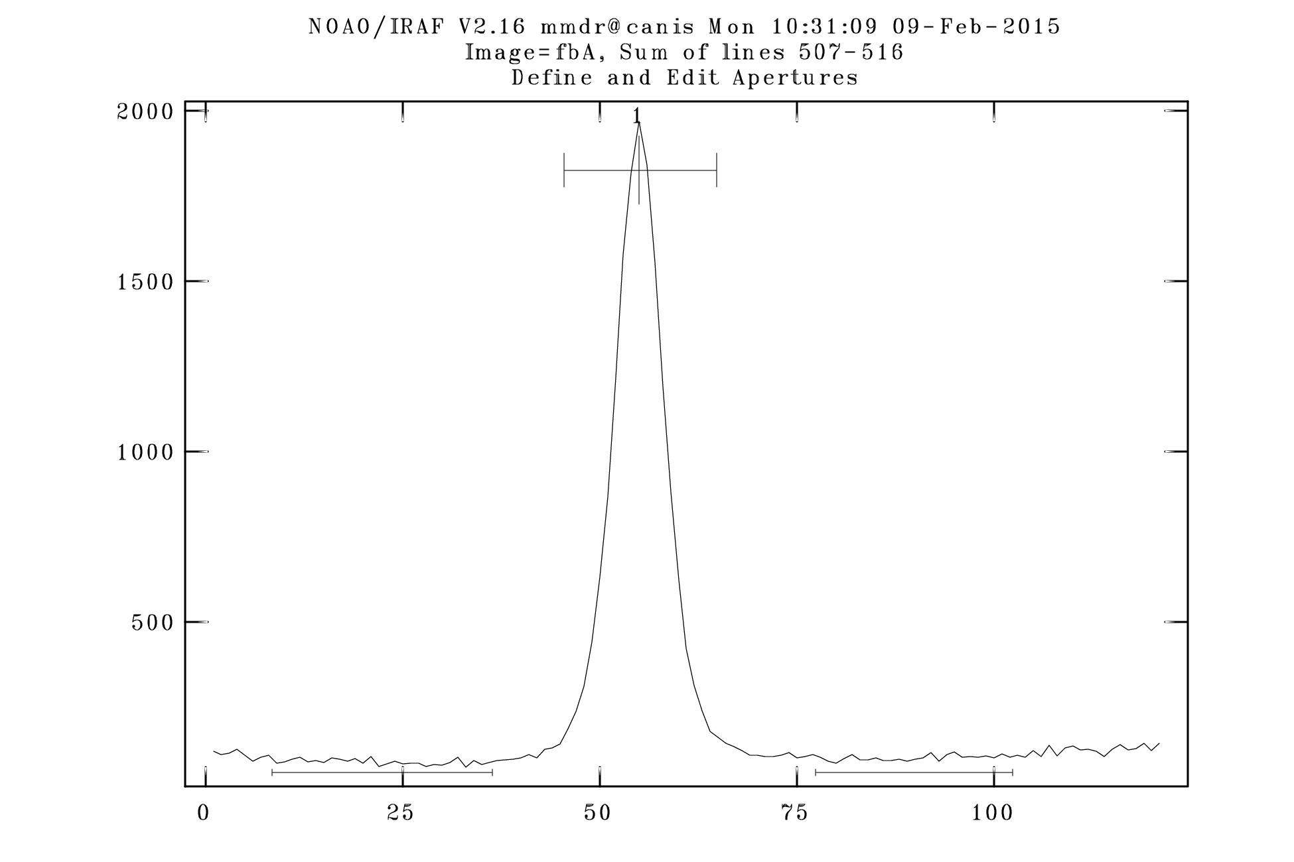

Figure 2: Aperture and Sky Background Definition

The utility takes the reference image whose aperture we just found, *fbtXs* and traced the centroid of the spectrum as a function of line in the same image, *fbtXs.fits*. (The parameter *refer= fbtXs* tells IRAF to go into *database/* and retrieve the fit. Note that the input image and reference image are the same in our case. The fit is carried out interactively so you can see how good the fit really is. Ideally, one should see a low-order function fit the data points quite well. Once the fit is displayed and you’re satisfied, type **q** to quite and **yes** to write the aperture to the database.

Now it’s finally time to extract the spectrum with background subtraction using the utility *apsum*. Type:

**unlearn apsum**

followed by

**apsum fbtXs.fits format=onedspec refer=fbtXs find- edit- trace- fittrac- back=fit extract+**

This routine creates a one-dimensional spectrum using the aperture and trace found previously. A spectrum should appear in the graphics window (possibly with a spike or two that can be ignored). Once the spectrum appears, then type q to quit and provide the output name for the spectrum (a carriage return to use the default). In this case, the spectrum fbtXs.0001.fits will be created.

It might be helpful to display this spectrum at this stage via,

**implot fbtXs.0001.fits**

It is now time to extract a spectrum from the associated arc lamp image using the identical parameters for the star, but with *no background subtraction*:

**apsum fbtXa.fits format=onedspec refer=fbtXs inter- find- edit- trace- fittrac- back=none extract+**

(You see why **epar** is now very helpful!) The arc spectrum is called in this case, fbtXa.0001.fits. In reviewing the arc spectrum, one should see a continuum around zero and a number of sharp emission lines indicative of the arc lamp used, FeAr (iron argon) in this case.

* + 1. The Dispersion Relation

Two spectra have now been extracted from the identical stellar trace, one from the stellar image, the other from the associated arc image. It is now necessary to wavelength-calibrate the data using the arc spectrum. First, make sure the line list, *FeAr*, available from the course website, is in your working directory. Then type:

**unlearn identify**

followed by

**identify fbtta.0001.fits coord=./FeAr**

Ignore any warnings that you may see. It is now up to the user to identify two well-defined lines from the spectrum before you. In Figure 3 two reasonable lines are identified. Typing **m** for mark with the cursor centred on the left line allows the user to enter its wavelength in Angstroms; in this case 6416. Now type **m** with the cursor centred on the right line whose wavelength is 6115 Angstroms. (Notice that longer wavelengths are to the left in this case, the opposite of the usual convention. This won’t cause IRAF any problems, however.)

Typing l asks *identify* to search the line list of the *FeAr* file and one should rapidly see more than 20 lines are automatically identified and marked as shown in Figure 4. At this point, type f which fits a low-order function for the dispersion relation after which a residual plot appears in the graphics window. Notice that the wavelength orientation is now more conventional. The RMS (root-mean-square) of the fit is displayed in the header information; typically < 0.1 Angstroms. If there is reasonable coverage over the entire wavelength range, then it would be justifiable to delete one or two lines with the largest residuals. To do this, put the cursor over the offending residual and type **d** and an × appears over the point. This is illustrated in Figure 5. When finished removing one or two lines with the largest residuals, type **f** for a refit. The RMS fit should decrease. You should print this plot by typing in the graphics window **:.snap** (or, to save the window as an encapsulated postscript file, **:.snap eps** which will generate a file in the working directory *sgiXXXXX.eps*).

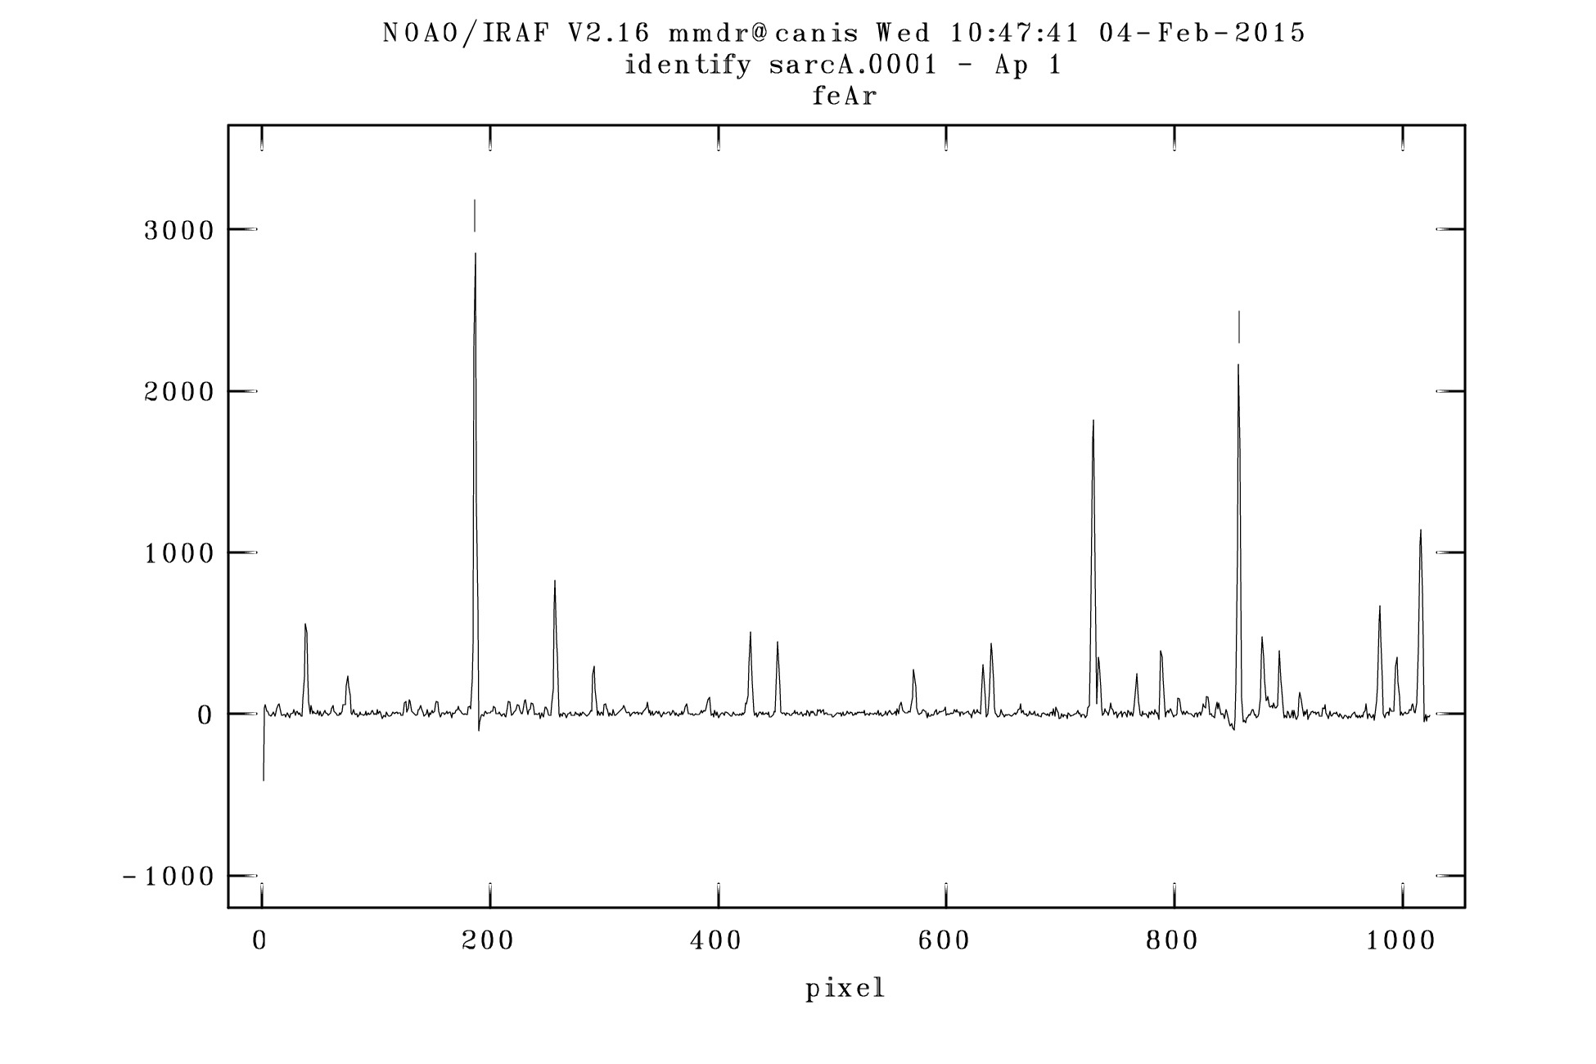

Figure 3: Identification of Two Arc Lines

Type **q** to return to the spectrum and **q** to exit from the utility after writing the information to the database. In order to attach this dispersion relation to the stellar spectrum, type:

**hedit fbtXs.0001 REFSPEC1 fbtXa.0001 add+ ver- show+ update+**

Examine the FITS header, particularly the last several keywords which have been added by the IRAF utilities.

Most astronomers prefer to analyze linearized data; i.e., intensities separated by equal increments in wavelength. In IRAF, this is done using the utility *dispcor*. Type

**unlearn dispcor**

followed by

**dispcor fbtXs.0001 wfbtXs linear+ confirm+**

In answer to the question, *Change wavelength coordinate assignments?* answer **yes**. You now get to provide a convenient starting wavelength and wavelength increment, for example. (A wavelength increment of 0.45 or 0.50 Angstroms would be reasonable.) There is no correct procedure here. It would not be prudent, however, to make the wavelength increment much greater than 0.45 Angstroms; this would unnecessarily coarsen the wavelength resolution.

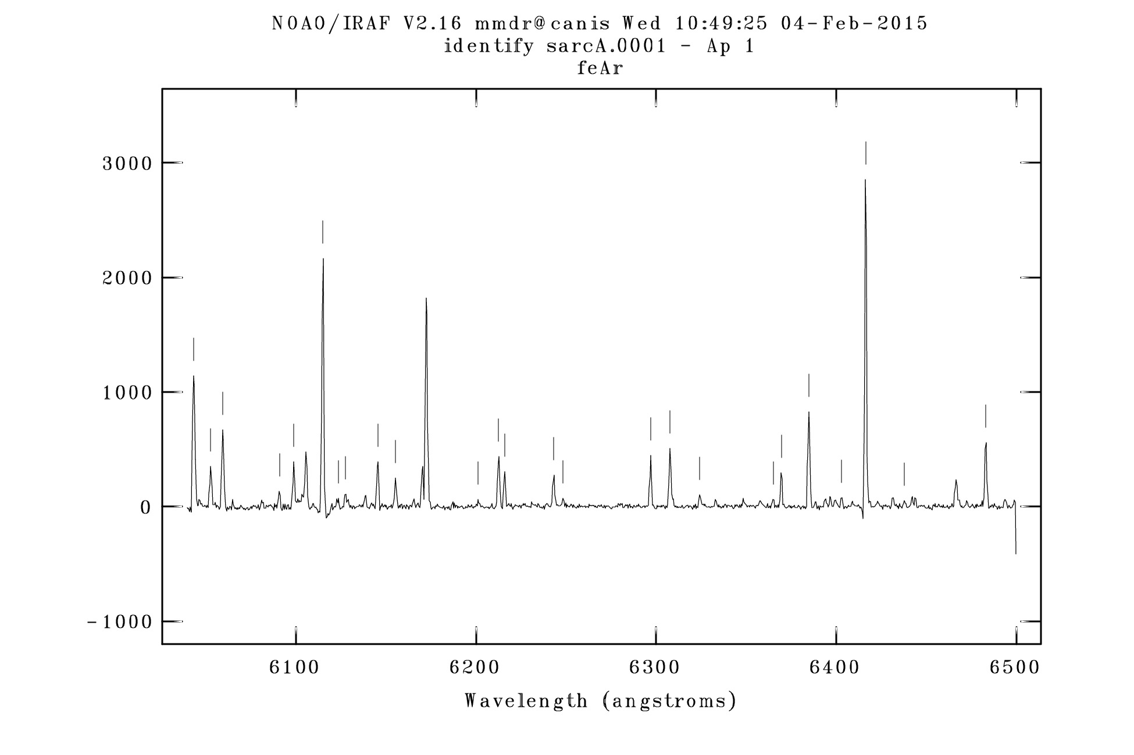

Figure 4: Auto-ID of Arc Lines in Linelist

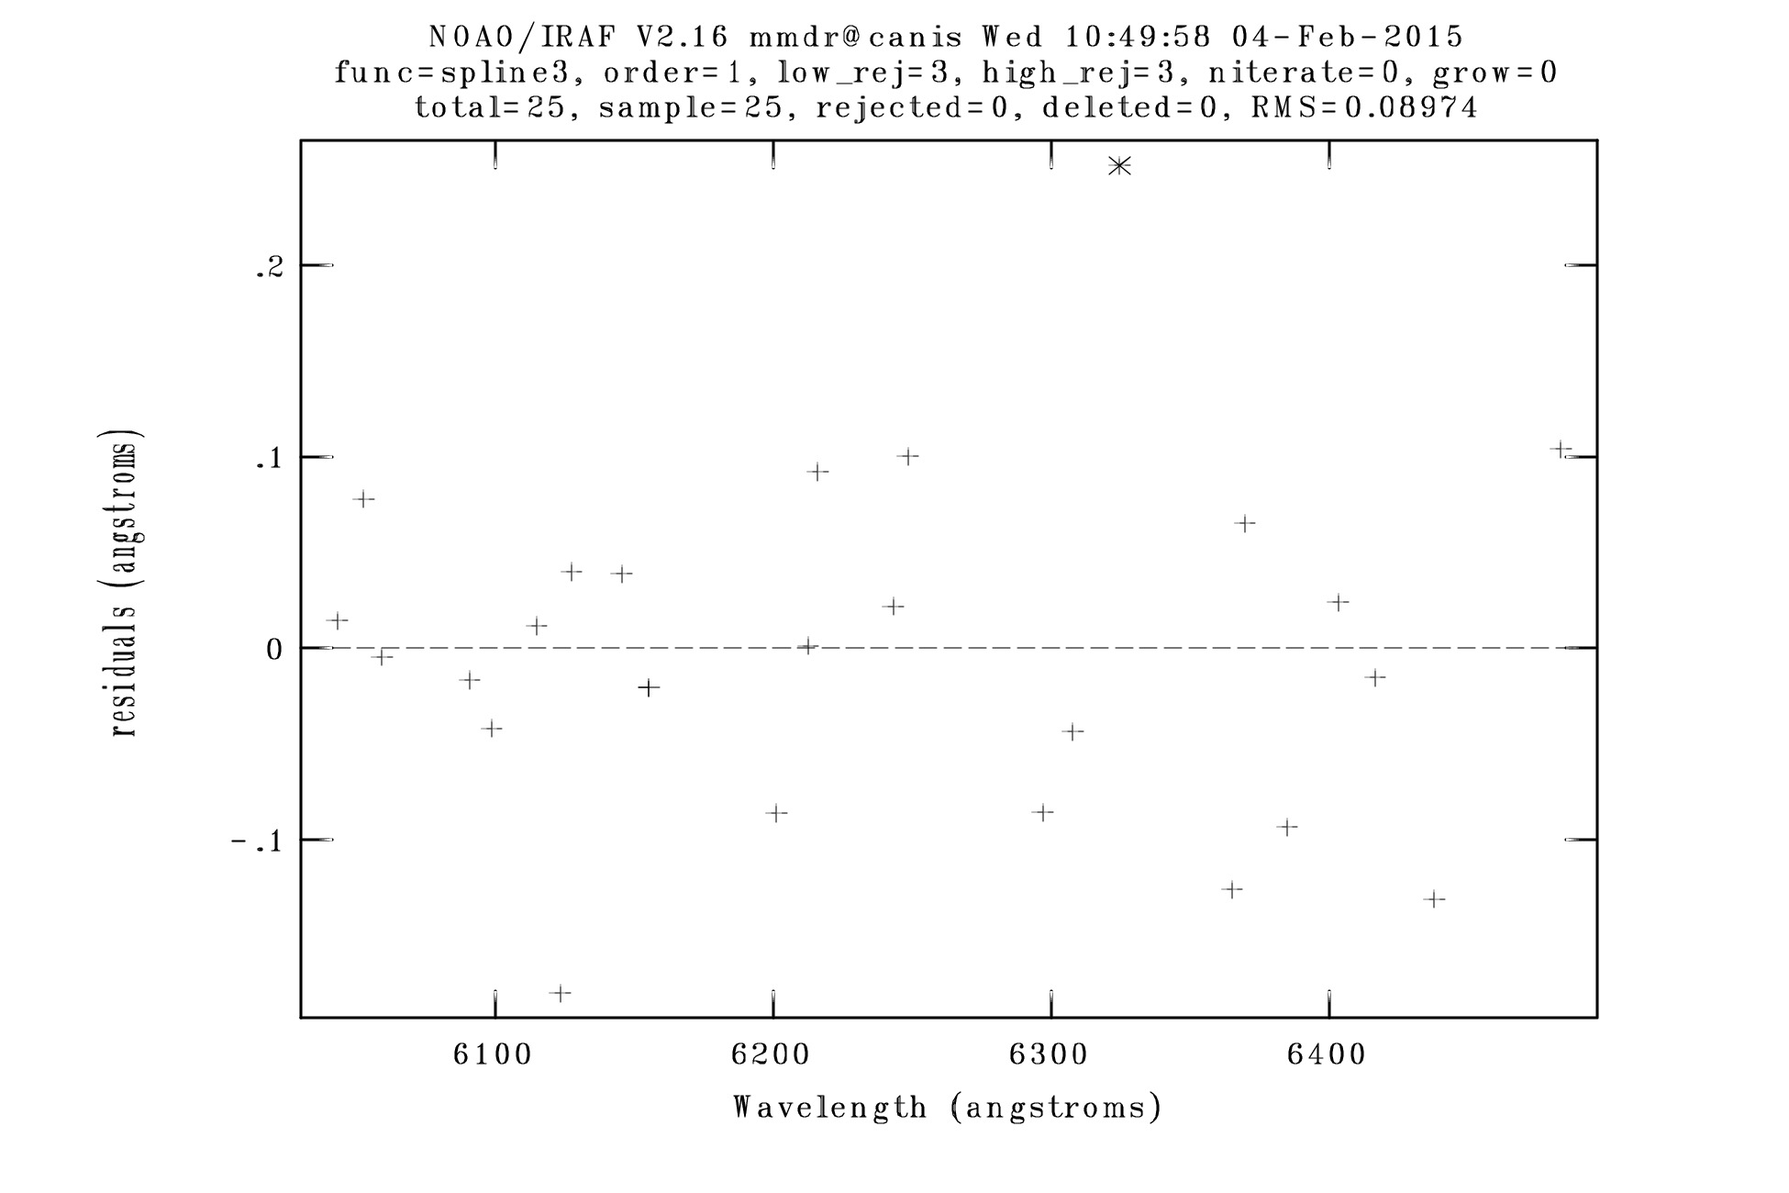

Figure 5: Residual Plot of Dispersion Curve

# Analysis

Now that the linearized spectrum has been generated, it is time to answer some questions for each of the two stellar spectra.

* + 1. FITS Header:
  1. Print the full FITS header of the linearized spectrum.
  2. Print the name of the star, its Right Ascension, Declination, the Exposure Time, the date of the observation, as well as the UT of the midpoint of the observation
  3. Find the latitude and longitude for the observatory.
  4. Compute the Local Sidereal Time (hint: use a Sidereal Time calculator from the web), the Hour Angle of the star at the midpoint of the observation, as well as the Airmass of the star at the midpoint of the observation.
  5. The slit on the spectrograph used to acquire these data could not be rotated. If it could have been rotated, to what position angle (nearest degree) should it have been rotated to acquire your star?
  6. Computer the operating temperature of the CCD as well as the actual gain (in e−/ADU) of the CCD

.

* + 1. Star Information:

1. One of the most comprehensive astronomical data bases is the SIMBAD website: (simbad.harvard.edu/simbad). Using SIMBAD (and course notes), provide some background information / properties of your “A” and “B” stars; for example, their radial velocity, proper motion, tangential velocity, space velocity, parallax / distance, apparent (and absolute) magnitudes for a variety of filters, other names / designations, etc.
2. All of the stars in this project come from the same catalogue as you can see from the FITS headers. In about 300 words, describe the LHS catalogue, its contents and the properties required form membership in the catalogue. Why are most of the stars in this catalogue late-type (i.e., red) dwarfs?
   * 1. Spectral Features:
        1. Using the IRAF utility, *splot*, plot the linearized spectrum of your star. Find as many of the atomic absorption lines of Ca I and Fe I from Table 2 as you are able. In each case, it is best to autoexpand the spectrum between cursors, and then use the k key to fit a Gaussian profile to each of the lines, one at a time. To do this, with the spectrum appropriately expanded, position the cursors just to the left of the line where you think the continuum would be and type **k**. Then position the cursor to the analogous continuum point just to the right of the line and type **k**. Information about the profile will appear at the bottom of the graphics window, including the centre of the (observed) line, the FWHM of the profile, and its equivalent width. Record all of these.
        2. Using the differences between the rest wavelengths and the associated observed wavelengths, compute the radial velocity of your star with an uncertainty. Compare your value with the value reported by SIMBAD. Your value is likely significantly different from the tabulated value. Suggest a reason for the difference. (This is not a trivial question, so give this careful thought.)
        3. While all of the “A” and “B” stars are late-type (M) dwarfs, you will have noticed an overall difference in the appearance in the two spectra. Describe the most conspicuous difference between “A” and “B” spectra (based on your pair) and try to find a physical explanation for this.

Table 2: Atomic Line Information

|  |  |
| --- | --- |
| Ion | Rest Wavelength (Angstroms) |
| Fe I | 6065.48 |
| Ca I | 6102.72 |
| Ca I | 6122.22 |
| Ca I | 6162.17 |
| Fe I | 6191.56 |
| Fe I | 6393.58 |
| Ca I | 6439.07 |
| Ca I | 6462.57 |

It would be helpful to provide a brief Introduction and Conclusion for this Winter-term report. Follow the instructions carefully. Do not use higher-level utilities or any other reduction program to reduce these data. Answer all the questions thoroughly.

1. Normally, Part 1/2 would involve the acquisition of spectra of a bright continuum and/or emission-line source and associated calibration data using on-campus instrumentation. This year, however, the appropriate instrumentation was not available and so raw 2D spectra were provided to the class from the outset; i.e., the project consists only of Part 2 of 2.